University of Glasgow
School of Engineering

Power Engineering 3 ENG3041

Lab 3: 3-Phase Induction Motor

Version 3

Student Name: 2941124B

Matric No: Daniel Borkovec

Introduction

In this experiment you will study the performance a squirrel-cage 3-phase induction motor. These motors are very important for many applications and absorb round about 45 % of all energy generated. They come in many sizes, from only a few watts up to several megawatts, and in many shapes, they can have the rotor rotating around the stator and different methods of cooling (e.g., TEFC – totally enclosed fan cooled, IP 55 (ingress protection, outdoor use) is very common, large machines can be water or oil cooled, drip-proof machines (IP 20, indoor use only) will have an internal fan and venting for air inlet and outlet and a fully submersible motor will be IP 68).

The 4 pole machine you are using is a total enclosed machine with natural convection cooling. It is low voltage (an educational machine designed to work at less that 50 V line to line) however it can be connected in various ways in a similar way to a normal 3-phase motors working at higher voltages.

We will look at the performance of the machine and carry out the following tests and measurements:

- Direction test
- No load test
- Locked rotor test
- Calculation of equivalent circuit parameters
- Obtains torque/speed and current Speed curves from equivalent circuit parameters
- Load test
- Comparison of results with simulation

Assessment

The 3 laboratory sessions account for 10% of your final mark in Power Engineering 3. You should have with you a bound laboratory book (with graph paper). Record ALL your measured results and any subsequent calculations in your bound laboratory book during the laboratory session, also fill out the necessary results in this lab sheet (this makes it easy for me to check your results during the session).
At some point after the lab session you need to write up the results (neatly!) and complete the associated analysis/theory sections before handing in your lab books before the end of the semester.

Note that you will not be assessed during the laboratory session so please communicate freely with supervisor/demonstrators – we are here to help you obtain accurate results and to help with any questions you have relating to the associated theory.

Experiment 1: Equipment Test

Warning – please get your connections checked by a demonstrator when first switching on and if in doubt. Take care when using the machinery – it is low power and low voltage but a nasty accident can still occur if you get things caught in it. Long hair should be tied back, ties should be removed or tucked away and objects such as fingers or pens should not be put into the rotating machinery.

Look at the equipment in front of you. The main piece of equipment is the induction motor and eddy current brake. The motor is on the left hand side and the eddy current brake is on the right. The eddy current brake is solely for loading the machine and is simply controlled from the dc power supply connected to it – increase the voltage and the load will increase. Now look at the 3-phase induction motor. At the non-drive end you will find a connection panel with six terminals and a connection for a thermistor. Ignore the thermistor connection and study the six terminals. These are labelled U1, U2, V1, V2, W1 and W2 which represent the three different phases. These can be connected in two different ways – in either star or delta. In the space below sketch the connections that you think represent a star and a delta connection. Get this checked by a demonstrator. Take U2, V2 and W2 as the star point connections.

Star Connection Delta Connection

Look at the other equipment you have in front of you. Identify the low voltage 3-phase supply (not always on bench, it is connected via the DOL starter), the 3-phase power meter and the 3-phase high resistance starter. This machine can be started by direct connection to the supply (called a dol
start – direct on-line start).

Inspect the plate on the induction motor. Rating plates are very important so never remove because it is then difficult to identify what the machine actually is!

Write down the details on the plate below:

Answer these questions:

- Calculate the Synchronous Frequency using the following equation:

N_{sync} = 120 × supply frequency f_{s} ÷ pole number P.

N_{sync} | 1500 | rpm

2. Given that Mechanical Power = Torque × ω (where ω is the speed in rad/sec) – and assuming the speed is close to the synchronous speed and convert to rad/sec (multiply by 2π/60). Calculate the rated torque:

Rated Torque | 0.318 | Nm

In reality the rated torque will be a bit higher than this because the motor will run at a speed a little below the synchronous speed.

Experiment 2: Direction Test

The 3-phase supply sets up a rotating magnetic field inside the machine and the direction is dictated by the phase sequence. To make the motor rotate in the opposite direction it is a simple matter to change two phases round (which reverses the phase sequence). In addition we wish to run the motor as lightly loaded as possible so we want to mechanically disconnect the eddy-current brake.

Procedure

Push the eddy current brake away from the motor - it should slide off the bed. Connect the motor up as a STAR connection; check the connection with a demonstrator.

Start with a DOL starter. Note the direction. Now verify that the motor will rotate in the opposite direction by stopping the machine, turning off the supply, and reconnecting with two phases switched. Restart and observe the rotation.

Does the motor go in opposite directions? | Yes

What speed does the motor run at in both directions? | 1495 RPM

For the rest of the experiment we will keep the motor running in the same direction and in star connection. For uniformity keep the motor connected so that it runs in the clockwise direction as you look from the drive end of the machine. Switch off and reconnect if necessary.

Experiment 3: No Load Test

We will now do a no load test. This is a simple test were we measure the input voltage, current, power and reactive power or power factor when the motor is running light. Therefore, start the motor and measure these parameters. The digital power meter has several pages so cycle round by pressing the red button to find them – look carefully at the units.

Parameter | Value | Units
Line Voltage (eg V_{RY}) | 43.6 | V
Line Current (eg I_{R}) | 1.79 | A
Total (3ph) input real Power | 27 | W
Total (3ph) input reactive Power | 131 | VAr
Power Factor | 0.2

Theory and Calculation

The induction motor essentially works as a transformer. The primary is the stator and the secondary is the aluminium cage on the rotor. At the synchronous speed the rotor is rotating at the same speed as the magnetic field set up by the stator current and therefore no current is induced into the rotor. As the rotor slows emfs are induced into the rotor cage, producing rotor current; interaction between the stator magnetic field and the rotor current will produce torque. Therefore we term the difference between the synchronous speed and the rotor speed as the slip which is given by
(1)

At standstill the slip is 1 and at synchronous speed the slip is 0. We can predict the performance of the machine by use of a per-phase equivalent circuit as shown below.
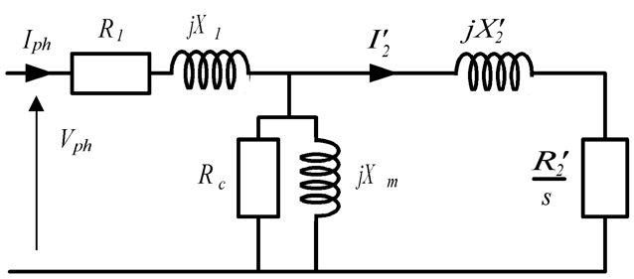

Since it is per-phase it should be excited by the phase voltage. For a balanced system the phase voltage (which is the voltage of one phase referenced to neutral) is the voltage between two lines divided by the square root of three (this has been covered in lectures!). Therefore

 | 25.17 | V

A simple approximation of the equivalent circuit is to move the magnetizing components to the terminals. This is because the magnetizing components have impedances which are much larger than the resistance and leakage reactances of the stator and rotor. This gives a circuit which looks like
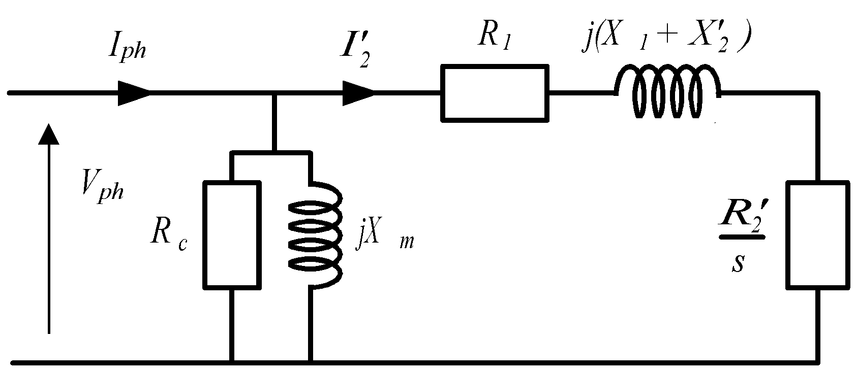

In the open circuit test s is approximately zero so that the rotor circuit is blocked. Therefore the equivalent circuit will be simplified to:

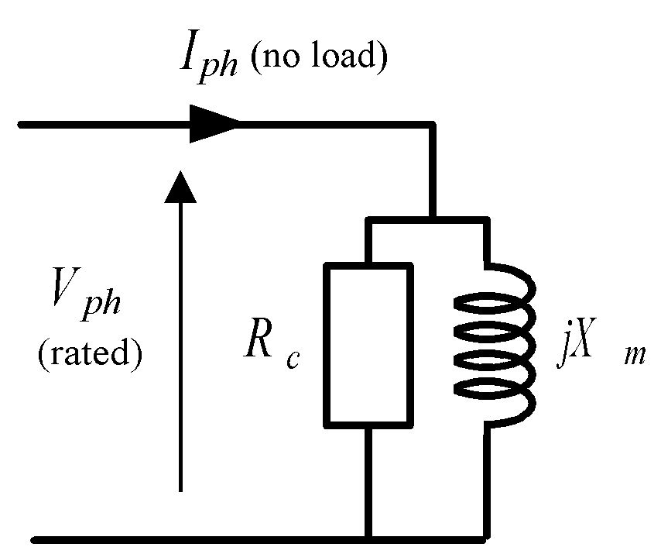

This test should be conducted at rated voltage. From the measurements calculate the values for Rc and Xm. Remember that power is absorbed by the resistor in the circuit. Reactive power may be a new concept to you. The points to bear in mind is that reactive power is absorbed by an inductor (and generated by a capacitor) and that

The circuit is per-phase so that to get the total power or reactive power then multiply the per-phase values by three. The unit of reactive power is Volt-Amp reaction (VAr).

Parameter | Value | Units
Rc | 70.39 | Ω
Xm | 14.51 | Ω

We now have two values in the per-phase equivalent circuit.

Experiment 4: Locked Rotor Test

This test is to obtain the other values in the equivalent circuit.

Procedure

Ensure that the motor is switched off. First push the eddy current brake back onto the induction motor and get this checked by a demonstrator. There is a slider on the eddy current brake at the shaft end that can be used to lock the rotor so slide this across and ensure that the shaft is locked to the brake.

The locked rotor test should be conducted as close to rated current as possible. The rated phase current is 2A which for a star connected load is the same as the line current. At zero speed full voltage will lead to very high current so this test is performed at reduced voltage by putting the resistor starter in the circuit between the supply and the meter. Get the circuit checked before switching on.

Switch on the system and quickly measure the input parameters then switch off after few seconds:

Parameter | Value | Units
Line Voltage (eg V_{RY}) | 29.4 | V
Line Current (eg I_{R}) | 5.19 | A
Total (3ph) input real Power | 213 | W
Total (3ph) input reactive Power | 155 | VAr

Also measure the torque on the dial at the end of the eddy current brake. Remember that there is a calibration factor as indicated on the brake.

Eddy Current brake Torque | 0.7 | Nm

The starting torque is approximately proportional to the square of the applied voltage so calculate the starting torque at full voltage (see Appendix 1). The starting current is approximately proportional to the applied voltage so calculate the starting current at full voltage (see Appendix 1).

Estimated full voltage starting torque | 1.55 | Nm
Estimated full voltage starting current | 7.69 | A

We will use this later. We now wish to obtain the input resistance of the machine so disconnect the supply and measure the resistance of one phase using a multimeter:

Stator phase resistance R1 | 1.78 | Ω

Theory and Calculation

In the equivalent circuit, when the slip is 1 (i.e., at start) then rotor circuit has a much lower impedance than the magnetizing circuit so that, at start, it approximates to
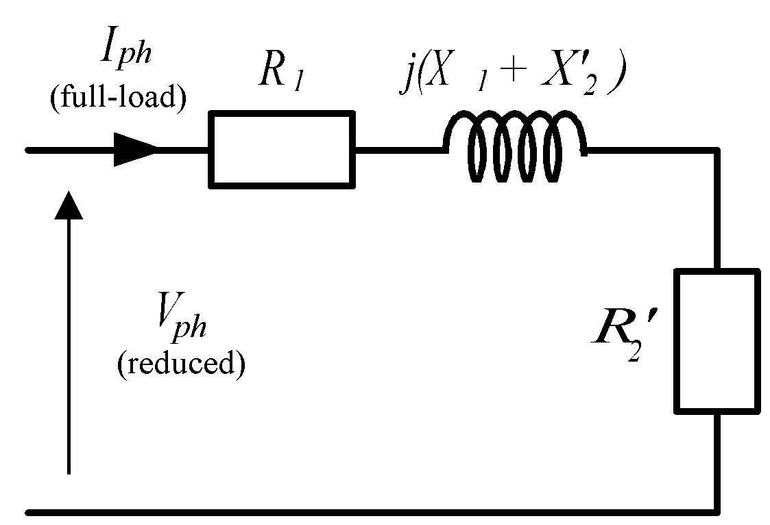

Therefore the values of X1 + X2’ can be obtained from the input reactive power and current and R1 + R2’ can be obtained from the input power and current.

Parameter | Value | Units
X1 + X2’ | 1.92 | Ω
R1 + R2’ | 2.64 | Ω
R1 | 1.78 | Ω
R2’ | 0.86 | Ω

Note: We can separate the R1 and R2’ using the stator phase resistance measured earlier.

We have now obtained all the circuit parameters for the induction motor. Remove the in-line resistances from the circuit.

Experiment 5: Load tests

Now load the machine by applying various levels of DC current to the Eddy Current Brake.

Fill in the table below with about three points equally spread in terms of torque from the full load current (rated speed) down to near zero current (near synchronous speed)
.
V_{line} ^{#1}  (V) | I_{ph} ^{#1}  (A) | Pin^{#1}  (W) | Qin^{#1}  (VAr) | P.F.^{#1} | Torque^{#1}  (Nm) | Speed^{#1}  (rpm) | ω_{r}  (rad/sec) | Pout  (W) | Efficiency  (%)

#1 – these values are measured and the other values are subsequently calculated from the measured results

For one test point (speed) only plot the values of measured torque, output power, efficiency and input current on the relevant simulation graphs and compare the results with the simulation results

Appendix 1

Estimation of Starting Torque at Full Supply Voltage:

Where:

T_{FV} = Starting Torque at Full Supply Voltage
T_{RV} = Starting Torque at Reduced Supply Voltage
V_{SF} = Full Supply Voltage
V_{SR} = Reduced Supply Voltage

Estimation of Starting Current at Full Supply Voltage:

Where:

I_{FV} = Starting Current at Full Supply Voltage
I_{RV} = Starting Current at Reduced Supply Voltage
V_{SF} = Full Supply Voltage
V_{SR} = Reduced Supply Voltage

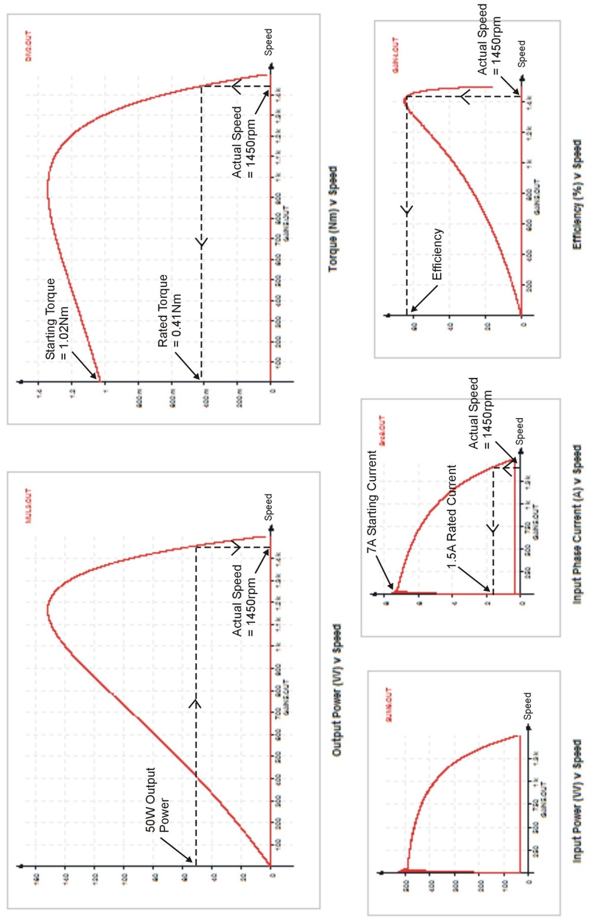

Dr Wenjuan Song
January 2026

